**INTRODUCTION:**

Innovate is a hands-on/project based program that supports student learning in real-world context with a focus on sustainable development, technological trends, citizenship and entrepreneurship. We use a student-centred approach known as andragogy. This model supports the adage that it takes a community to raise a student much like it takes a village to raise a child. Students innovate outside of traditional curriculum to imagine new possibilities, create, ideate, reinvent and improve the wheel. They are encouraged to fail and try again, connect with the greater community, work on solutions to glocal (global and local) problems, and discover career pathways. In this way, Innovate adapts education to demands of the globalizing world and is a response to what we call the *pedagogical paradox* where we want students to think outside of the box but we keep placing them in classroom boxes. Such box-like environments can isolate learning from the world we all participate in. The world is changing rapidly from climate change and technological development. Education needs to help people participate in and shape the world around them as agents of change. Participation requires the development of new sets of skills, attitudes, competencies and knowledge which are facilitated through partnerships.

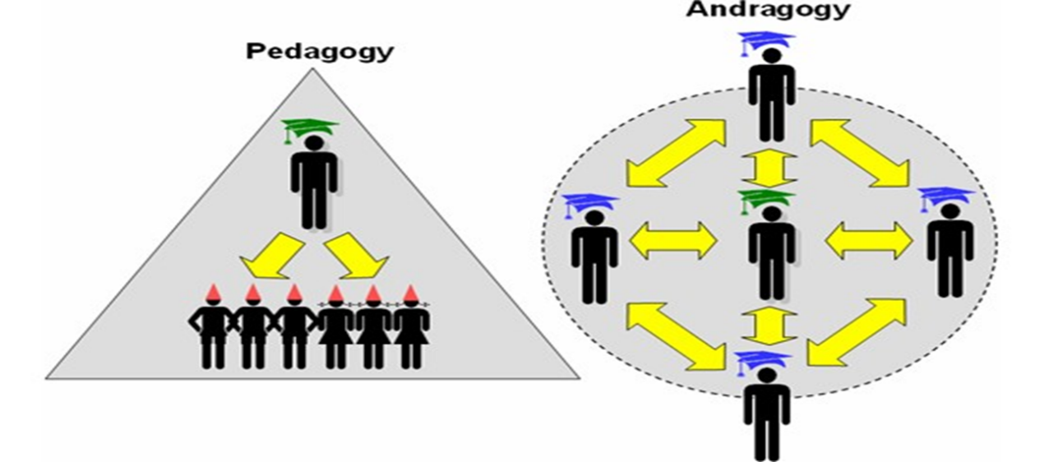

*Image of Andragogy. Online Source: https://elearningpractitioner.wordpress.com/?s=andragogy*

Innovate has been developed over the past 10 years through trial and error.  We learn as we go through student projects that are connected to partnerships. Innovate seeks ways to extend learning beyond the 4 walls of the classroom - to work with the greater community. This approach is valuable in that students have greater exposure to diverse expertise and experiences making learning more authentic and meaningful*. Partners also* provide expertise, access to resources, funding, field trip opportunities, and mentorship and support students in transitioning to the world of work.

**PROCESS:**

Innovate is a flexible program that focuses on student interests and needs instead of standardized curricular outcomes. The process is disruptive to our common sense way of experiencing traditional approaches to education. *If we want different outcomes in the world then we need different approaches to learning.* In Innovate, the teacher assumes the role of facilitator and ensures that students identify and work towards their learning goals. This is similar model to *independent studies* in post-secondary whereby a student can approach a professor with a project/course idea. They draft a learning plan, timeline and assessment. The student receives the same amount of credits as they would in any other course upon completion of the determined outcomes. At the high school level, the Innovate process aligns more readily with career pathways, citizenship and entrepreneurship.

Students can better transition to life outside of school through learning in real world context. For example, in a career, people do not work with employees of the same age group or from similar neighborhoods as students do in school classrooms. They work with people from all walks of life and are required to solve problems and complete tasks. It is critical that we offer students opportunities to engage and learn with others outside of their immediate school life.

Learning must also mimic the real world of citizenship. When youth see how they can participate and contribute to their society, they are more likely to see themselves as valued stakeholders with the ability to strengthen their community. As students are required to plan a project, they develop entrepreneurial skills. Innovate requires students to participate in assessment and every student must grade themselves and submit a self-evaluation. This allows students to reflect on their performance by revisiting their original learning goals and assess their abilities. For the grade to be accepted, the facilitator meets with the student who then justifies their grade by having to provide evidence for their assessment. Such as process allows students to examine their strengths and weaknesses and teaches them to speak confidentially about their abilities. This is a critical skill needed for job interviewing.

**How it works:**

Innovate teachers assume the role of a facilitator to:

* Engage students in joining the program and help them create individual or group projects.
* Facilitate projects by assisting with planning, identifying resources, and determining assessment (create rubrics for self-evaluations and final project presentation formats)
* Students chose when they have finished and when to review their self-evaluation with the facilitator to determine a final mark.
* Determine curriculums that will align with the student project(s) by searching the province’s programs of study.
* Establish partnerships relevant to students learning goals and needs
* Encourage students to work in the community and organize events, present their projects to the public, network, etc..
* Build media relation and seek media attention for student work as much as possible. Images and stories in the news can be used in student portfolios that complement their resumes and bring greater attention to what is happening in schools, another way of engaging partnerships and supports.
* Connect with teachers, students and administration from other schools to build capacity. We have gone as far as setting up Innovate displays at Teachers Convention and at other school’s club day.
* Seek funding through sponsorship and grant writing to support purchasing of materials, equipment and field trips. Most industry and large organizations (NGOs, Rotary clubs, government institutions) have a local community improvement or youth engagement funds.

Engagement occurs through multiple means. Teachers can start an environmental lunch club, create a class project that extends outside of class time, host an iconic event such as a green career fair, ask students throughout the school to volunteer, create field trips that involve volunteering in the community or sign up for field trips organized by outside organizations with an environmental focus (helps build networks) and advertise in school newsletters, website and announcements that projects will get students credits. Innovate facilitators need to seek the support of their administration so make sure to keep an ongoing dialogue of your plan of action.

The facilitator discusses the process of earning credits with students and again seeks admin support to make sure projects align with curricular outcomes. For individual projects, students normally complete a brainstorming activity on their interests. Students then work on a project proposal, a basic template that helps students outline their project. The proposal is a google document that includes questions such as:

* *Summarize the theme or "BIG IDEAS" for this project. What is that you would like to learn about?*
* What is your driving question? (this is an open-ended through line question that cannot be answered yes or no, it drives the research).
* Identify 3 questions you would like to answer for your project.
* Describe how your project applies to life outside of school? What makes this project important to the community/world around you?
* My main GOAL (goals) for this project is...(what will be your end product?)
* Three objectives I want to achieve are…
* List a minimum of THREE different types of resources you will use. Can be people.
* Consider 2 ways you will evaluate your progress throughout the project?

Review the finished proposal and offer feedback to help make it stronger. Align initiatives with curriculum in non-traditional or locally designed credit based courses. In Alberta, students earn high school credits through approved Alberta Education courses called **special projects** (1 to 5 credits approximately 25 hours of work per credit) or specialized 1 credit **CTS courses** (Career and Technology Studies). Special projects credits are designed to recognize work undertaken by students on an individual or small group basis.

Special projects credits perform two major functions:

* Students become involved in the selection, planning and organization of their own programs.
* Students pursue activities in which they have considerable interest or ability but which are not within the scope of the regular curriculum or the programs being offered in the school.

(https://education.alberta.ca/special-projects/?searchMode=3)

Credits are earned outside of traditional class time and occur during morning, lunch, spares, after school, evenings and weekends. There is no official start or end time as Innovate aims to be as flexible as possible to engage and accommodate students from a variety of backgrounds and learning needs. The facilitator signs students up for courses or through the school’s clerk. In Alberta, we create a heading such as Innovate or Environmental Stewardship and the clerk registers students for the courses as soon as the student starts.

Depending on the student’s desired start and completion date, I require them to provide me with a weekly or monthly update of their progress in point form (5-6 things they have done) via email or google document. I also ask them to list 1-2 “next steps” with each submission. By the end of the project, they’ve usually sent me 3-6 brief summaries. As credits are based on a relative 1 credit per 25 hours of work, as well as performance, I asked them to estimate their time commitments. This includes extended processes of the learning that are not always included in traditional classrooms such as brainstorming, some field trips, attending events, conversations with peers, family, etc… about their project, and communications with their community partner(s).

The Innovate Coordinator needs to make sure students are accessing the expertise and resources they require to meet their learning goals. Finding partnerships might seem daunting at first but once you get started, a network will develop through people making recommendations of who might be interested. My most recent partnership is APEGA (Association of Professional Engineers and Geophysicists of Alberta). I contacted their outreach coordinator because it is their job to ensure their members volunteer a certain number of hours per year. I invited them to some events and had their members volunteer to assist students in iconic group projects. Another method of acquiring partnerships is to present. I present regularly on Innovate initiatives at teacher PD, educational organizations events, and conferences because it stimulates a conversation and gets people interested in the program.

To further strengthen partnerships, I have volunteered with several groups to provide greater service to students. Organizations include SESA (Solar Energy Society of Alberta), ACEE (Alberta Council of Environmental Educators), Alberta Emerald Foundation (judge for environmental awards), Green Building Council of Canada (judge for greenest schools), Dad’s Matter Volunteer (organize science nights to elementary students), Edmonton Public Schools Career Pathways subcommittee on Natural Resources and Environment (present to schools on 3D printing, energy auditing, aquaponics, air quality, etc…). Volunteering has been essential in developing the Innovate program as I can directly communicate student needs to these organizations. This information allows them to better direct their efforts in supporting youth.

**The Program:**

Innovate began in 2007 when I volunteered with the environmental club at Queen Elizabeth high school in Edmonton. Students were eagerly planning to expand our recycling program by installing small blue bins in each classroom. While this was a worthwhile endeavor, Edmonton was already a renowned recycling centre. I asked the members if there was anything else they wanted to do and they simply answered, “like what?”. I said, “I don’t know, how about we become the first high school in Edmonton to install solar panels?”. The students responded with enthusiasm as no one had pushed them to think about other possibilities. I quickly realized that I had put my foot in my mouth. I had no idea how to achieve this goal but I was resigned to help them figure it out. Our goal was to create a solar demonstration sight to learn about this emerging technology that was becoming more readily available. We were preparing youth for the future.

We faced a lot of resistance from people’s reactions to change and from the provincial politics of the day. Many decision makers attempted to discourage us due to inconveniences, challenges to roof maintenance, feelings of disruption to the Alberta oil culture, misinformation, and many uninformed opinions about our motivations. Each counter-argument required us to brainstorm solutions to address those concerns. Four years later, we had raised $26,000 to install five 185 watt solar panels. We continue to monitor clean energy production from these FIVE panels via internet displays. Through these efforts, the Innovate program was borne and many projects followed. A critical piece to this learning curve was to understand that knowledge insists where it most resists (adage by Jaque Lacan). Today, solar technology has become normalized and is not considered a societal threat, it is an added benefit environmentally and financially and people are coming to trust the technology.

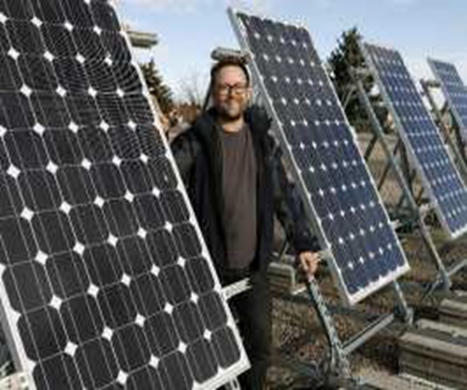

From here on I set out to create a credit-based program that would help students develop their own learning opportunities and to show them what’s possible. Students decided the name of our new program should be called SLISE which stood for “*Student Led Initiatives for Sustainability Education*”. SLISE became an environmental program known by many schools and organizations that supported our initiatives. The name however, was long winded and we changed it to Innovate which encompasses a wider range of opportunities associated with sustainable development. Through trial and error, I learned many ways of engaging students and bringing them into the program.

Our next project involved supporting earthquake relief efforts in Haiti. I was teaching about Haiti in my social studies Knowledge and Employability (K&E) grade 10 class. The earthquake hit there in October of 2010 and many students were troubled by the devastation. I decided to turn current events into a living social studies lesson. Many of my original Innovate students were the top academic performers in the school. I recognized a need for students of differing abilities, ages and backgrounds to learn to work together on solutions to real world problems. I challenged by students to figure out how we could help Haitians. We researched as a class and discovered theyt access to lighting for night time activities including community development, schooling, and medical practices. Normally, Haitians rely on kerosene lamps which are a fire hazard, toxic to breathe and provides poor lighting. Children, for example, were working in the daylight, helping to rebuild their communities and therefore did their studies in the evening. They had to sit close to the kerosene lamps which affects their eyes and lungs. While Innovate was focused on the solar panel project, we decided to consider providing Haitians with an alternative, safe and environmentally friendly source of light. We discovered StarEco Works, an organization who designed and built a robust solar lantern for Jane Goodall. The cost per lantern was $250. We appealed to the business community and found a generous donor who not only gave us $2500 to build 10 lanterns but also took them to Haiti via his boat. StarEco Works agreed to conduct a workshop on how to build the lanterns. I sought approval from admin, excused kids from class and booked a room for the afternoon. One K &E student, named Tom, had learning disabilities and did not speak when spoken to or smile. I was worried about him. But when the opportunity came to get out of the classroom and build something, Tom was more than happy to join in the fun. He was the first student to complete his lantern and didn’t know what else to do. I asked him if he could walk around and help others build their lanterns. Tom helped some honors students finish their lanterns and began to see he had a natural talent and could contribute to a group effort. He was instantly motivated and sought other projects. Several months later we were invited to present to hundreds of students and professors and a business and tech conference at a local post-secondary institution. Tom, who originally didn’t find much success, stood up in front of hundreds of people he never saw before and told them about our project. He became an Innovate student for the next 3 years and mentored many students new to the program.

The workshop demonstrated valuable learning outcomes that are not available in traditional classrooms. Students used science and physics to learn about solar light, measured lumens and visibility with math and physics, and wrote letters in English and French to the people who would benefit and stuck them inside the lanterns. After the lanterns were delivered, our donor gave us a contact, Samuel, who worked for a charity in his home of Ile a Vache in southern Haiti. Samuel was given a phone and he took pictures of people with the lanterns. He emailed descriptions of how they were helping the community. Students saw their direct impact on helping transform a community which made social studies more meaningful. I learned that Innovate served to bridge the different subjects and connect curricular outcomes to achieve greater goals whereby students could apply their education in real world context.

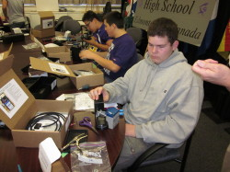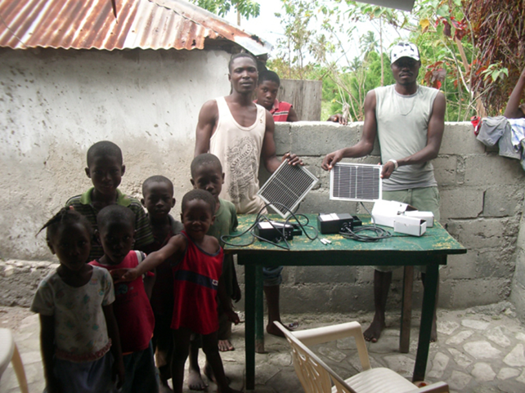

*Building lanterns with StarEcoWorks Haitians receiving lanterns*

The lanterns project connected us to many partners. A United Nations soldier got wind of Innovate’s efforts to assist Haitians. We invited him to present to our group and a number of potential new Innovate students. He taught us about challenges to humanitarian initiatives and we learned that water borne illnesses such as cholera are either killing people or weakening their ability to rebuild their own communities. Students from another high school organized an event to raise awareness to water issues. They invited us to participate in the “*Walk for Water”*. Hundreds of students walked for 8 kilometers carrying two 4 litre milk cartons full of water to learn about how many people are challenged to spend most of their days just accessing dirty water. These people often cut down forests to burn wood to boil water. This creates a lot of environmental devastation and contributes to climate change. It also reduces the soils ability to regenerate and retain water needed to subsistence.

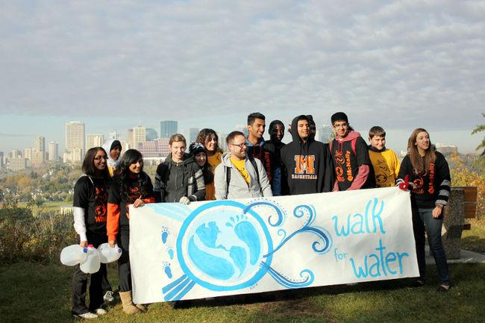

Students embarked on a campaign to raise $11,000 to purchase 1500 life straws that were delivered directly to people in need. They drank dirty water with lifestraws on TV and other schools to show the effectiveness of this technology. Students from different schools were learning together and from each other on water issues building a greater community of youth committed to bringing awareness to this critical glocal problem.

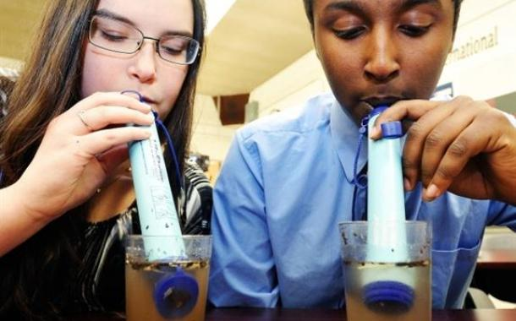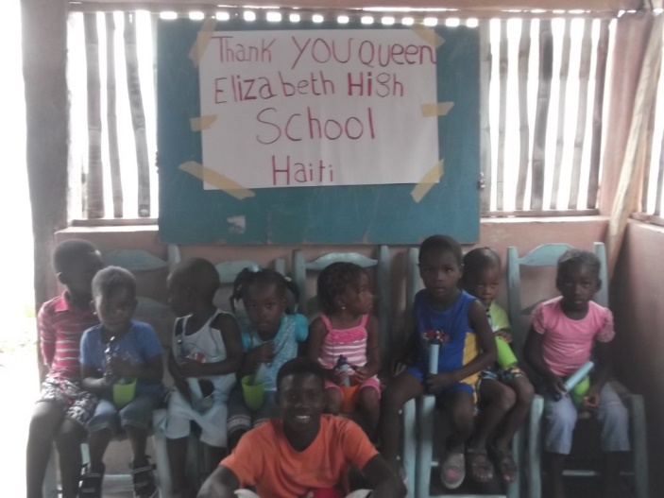

*Here are two students demonstrating lifestraws “who can drink the most dirty water the quickest” on the front page of the Edmonton Journal December 12th, 2012.*

AIR QUALITY and CLIMATE CHANGE

Certain initiatives are borne out of classroom discussions that capture the curiosity of students’ and extended to school wide projects. When I was in a classroom, I had an aquaponics system and indoor gardening systems. The classroom was very green. The only sources of light in my room were from the sun and UV generated light bulbs for the plants. Students, in my 4th block class (last class of the day), noticed they were more alert than in other classes. It wasn’t because I was a more engaging or interesting teacher, there were other factors at play. I asked students figure it out which turned into a study called “*Boring Classrooms or High C02 Levels*”. Through observations, students noticed that plants and UV light have a psychological calming effect on people, especially when its cold and dark outside. Also, our eyes are adapted to UV light and not light produced from florescence bulbs which are normally found in classrooms. This suggested that students’ brains did not have to work as hard to process information as they used more natural forms of light. Plants and humans have a symbiotic relationship where we breathe out C02 gas that plants absorb and produce oxygen which we breathe. We purchased a C02 meter and discovered that at 800 ppm of C02, people’s physiological response is to get sleepy. We tested classrooms with approximately 30 plus students who breathe all day consuming 02 and breathing out C02. Students wondered if the ventilation system wasn’t exchanging air quick enough at the level of a desk where kids sit almost all day. We found that classrooms without plants and closed windows (due to winter) began at around 4-500 ppt/million and could reach over 800 ppm by the 4th block. My classroom was always around 300-400ppm. This research became a great way to study the effects of Climate Change in an indoor setting; basically the world will just become sleepy with the more carbon we emit.

The project encouraged more students to participate in Innovate initiatives such as growing vegetables, maintaining the aquaponics system and building green walls of recycled materials (old political signs, 2x2 boards, soil fabric, growing medias, plants) and with air quality enhancing tropical plants. Students also developed a poster and speaking presentation which was delivered to decision-makers in city hall. The project has had influence on many schools, school boards and outside organizations that are rethinking design of work and learning spaces to improve conditions.

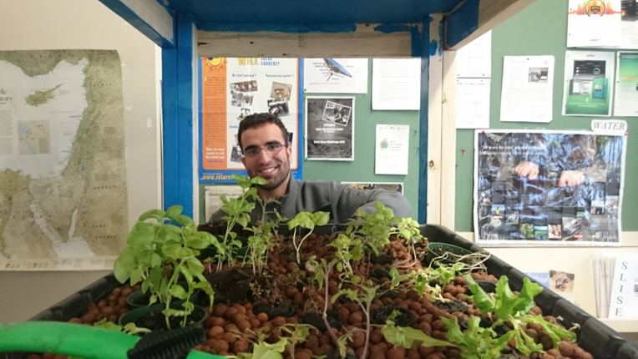 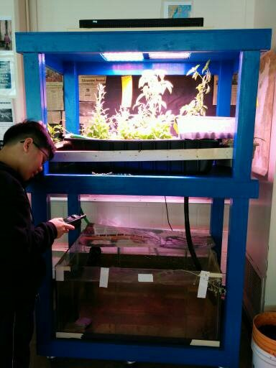

*Students build an aquaponics system to grow vegetables from fish waste.*

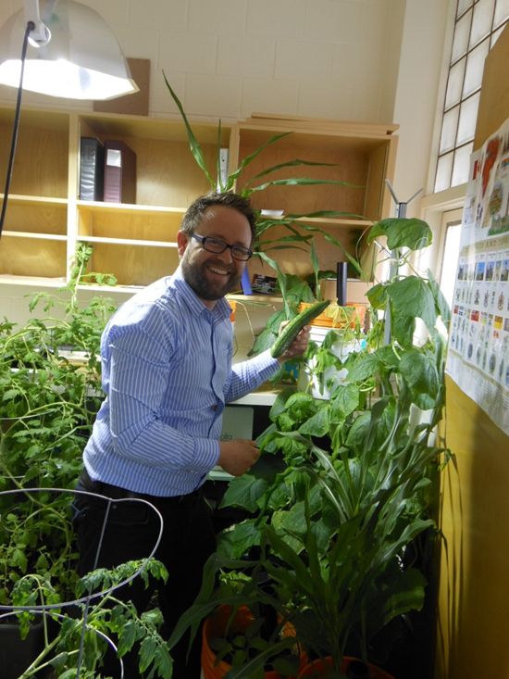 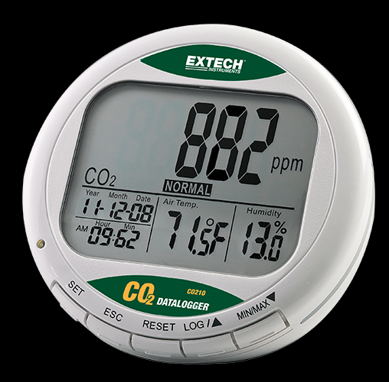

*Part of my classroom that was “junglefied with plants and grow lights. Typical C02 Meter.*

**Building a community of Innovative thinkers: Engaging students from other schools**

The Innovate Program has worked tirelessly to build capacity for higher impact projects that involve students and teachers from many schools and multiple stakeholders in various issues. I spent years developing relationships with members of other educators to understand a wider range of project possibilities, to create a larger community of Innovate youth, and to build capacity to develop and carry out district wide projects. I began this process with the realization that there is usually a teacher or two at most schools who run an environmental club. I picked up the phone or emailed the school to find out who they are then connected with them to see if there is synergy in the types of projects that groups of students are working on. This community eventually formed and many projects followed.

TREE PLANTING

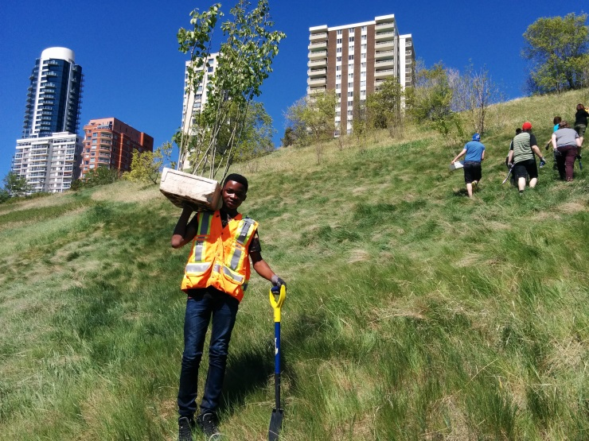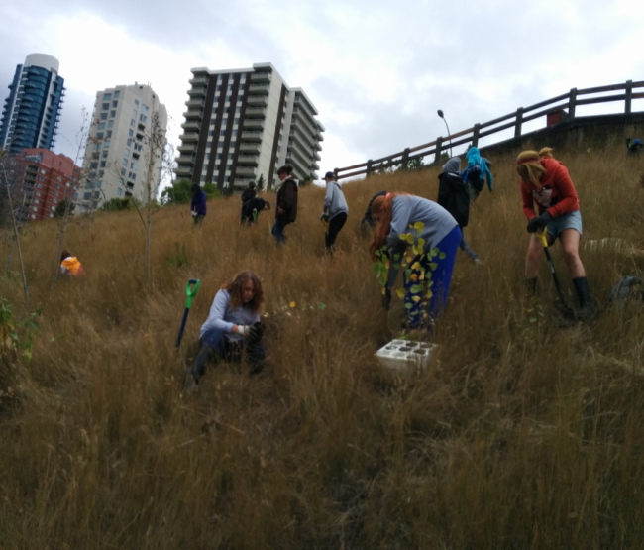

*Students from a elementary, junior high and high schools from different parts of the city converged on a downtown location to plant over 1200 trees in a spirited initiative that strengthen our city community. Edmonton has a tree growing program called “Roots for Trees”. They provided the shovels, trees and locations. Youth worked together from different backgrounds and age groups as citizens with a shared common future. They will always remember this project and will see the trees grow over a lifetime.*

GREEN CAREER FAIRS:

One year, we organized “*Green Career Fairs*” in 5 Edmonton Public high schools. Over 120 vendors (30-40 per fair) set up displays at each school and over 6000 youth participated to learn about careers with an environmental focus. I applied for an Edmonton Community Foundation Grant and was awarded funding to cover my time and mileage to help groups of students organize the events at their respective schools. Volunteer youth created questionnaires, signed out giant floor maps of North America from Canadian Geographic that depicted developments and migration routes of iconic species to focus on conservation, and wrote grants to purchase shirts they designed, snacks and door prizes.

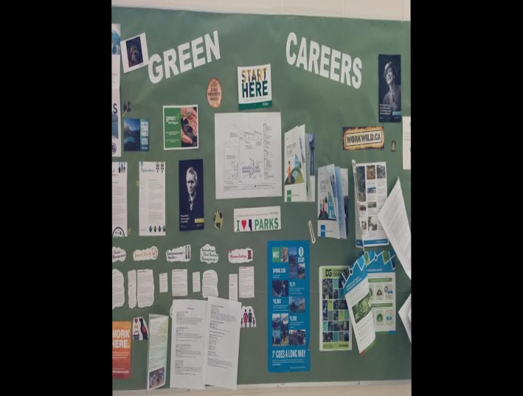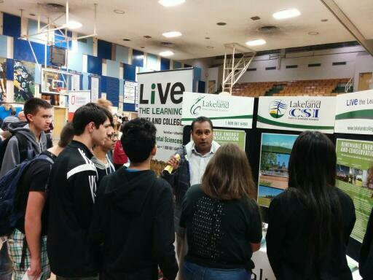

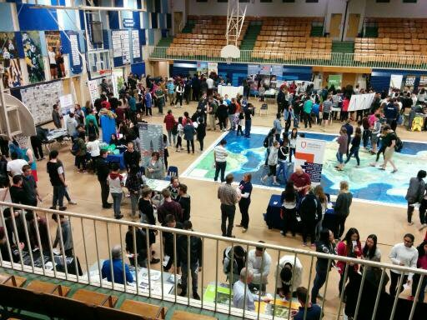 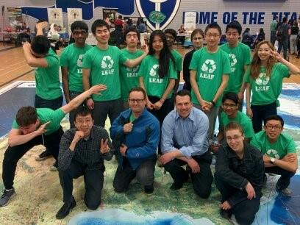

STUDENT-CITIZEN PROGRAM

The next year, students wanted to work on action projects aligned with city environmental strategies. The City’s sustainable development department and the office of public engagement supported the idea. Groups of students from 4 high schools participated in City Hall Days. Students research city directions and selected an action theme prior to the event such as urban beekeeping and energy efficiency of street lights. They came prepared to talk about their potential initiative. We began with a debate in City Hall chambers where students’ role played the mayor, councilors, and concerned citizens. They discussed and voted on the pros and cons of their action ideas. Afterwards, students met with city hall staff from each area of student interest to learn more about city strategies. Students began to understand the complexity of organizing society and how decisions are made and where the best place is to go to influence change.

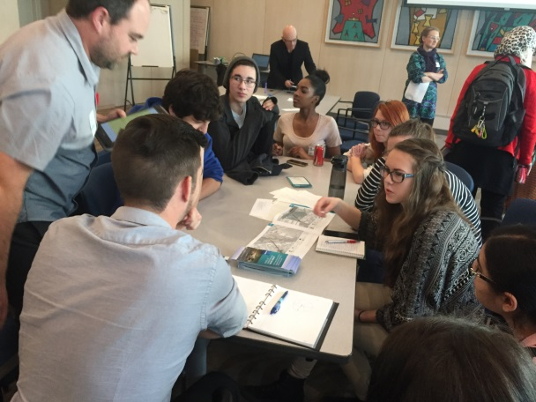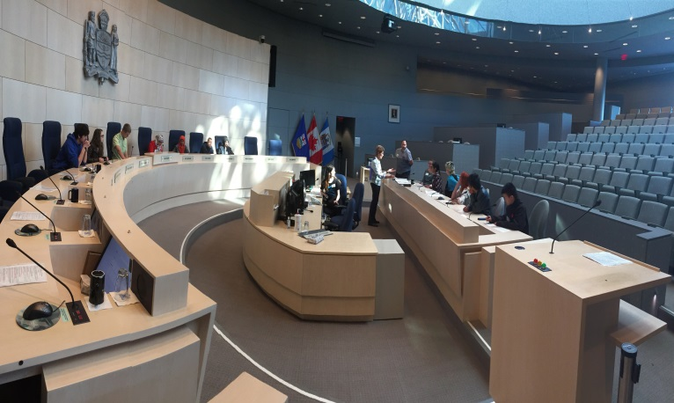

BUILDINGS THAT TEACH

While we prefer to work in the community, it can be very challenging to try and always work outside of a school, especially with large numbers of students. There are costs, liabilities, supervision, transportation, and so on. We work outside of school as much as possible but have come to recognize the wealth of learning opportunities that exist within the very buildings where we spend most of our time. School infrastructure and non-teaching staff have great added value in facilitating student learning. A School is designed to offer us protection from the elements with heating, cooling, waste management, clean drinking water, etc... There is a great amount of energy and labour required to make sure a building meets a certain standard. This presents an incredible number of learning opportunities that exist within our immediate reach in a recent initiative called “**Buildings that Teacher**”. We currently focus on school buildings to study:

* Design Concepts: landscaping for things like onsite water retention and trees for wind protection, building location solar passitivity potential, natural light, and air quality.
* Energy Efficiency: good and poor uses of energy

We can use our school buildings to complement existing curriculum or for project-based learning that bridges the different subjects. One reoccurring project is to study how a school uses electricity so that students can become energy aware while doing memorable action projects to reduce waste from inefficiencies. Such projects help students develop sets of skills, attitudes and knowledge that become transferable to life outside of school. Energy is measured using math and physics. Students present their results and solutions using English and social studies. They also interview custodians and other maintenance labourers to discuss operations. Students and maintenance staff often learn from each other which can help the school become more efficient.

Some of the most interesting curricular ties include making sense of the laws of thermodynamics:

* 1st law: Energy can’t be created or destroyed, only transferred from one form to another. Solar photovoltaics, for example, are an opportunity to study energy behavior as light energy is converted to electrical.
* 2nd law states: as energy transfers from one form to another, some of it is lost as heat, called entropy. This an opportunity to problem solve and reduce entropy or waste from inefficiencies.

Types of studies in this area consist of visible and invisible sets of data. For the visible study of electricity, we do energy audits. We begin listing all the things that use energy in the room, then students walk around the school and observe good and poor uses. We use a variety of tools such as thermal scanners to determine heat loss, lumen meters to record how much light we use at any given moment in a certain area and DENT meters which record light over time (perfect for places like washrooms to see how long lights are actually left on for). Students have compared their results to industry standards and have suggested that we need about a 3rd of the lighting that is recommended for many areas such as hallways and doorways. We are currently working on a study where we decommission a certain number of bulbs, then record lumens and survey students and staff about their comfort levels in the controlled areas. Ideas that have surfaced include: LED bulbs, less bulbs per square foot, photo sensors and so on. This can lead to large savings in terms of reduced energy needs, less installation or replacement of bulbs, reduced cost of labour, and reduced C02 emissions and tax.

To study the invisible aspects of energy consumption, we installed smart meters at Queen Elizabeth School to study the overall usage of the building. While Innovate monitored clean energy produced form our solar panels, we had little idea of what percentage of electricity we were offsetting compared to the overall school energy usage. Smart meters provide us with 3 data points in real time:

* how much energy we were using at any given moment,
* the cost of this energy and
* the carbon emissions equivalent.

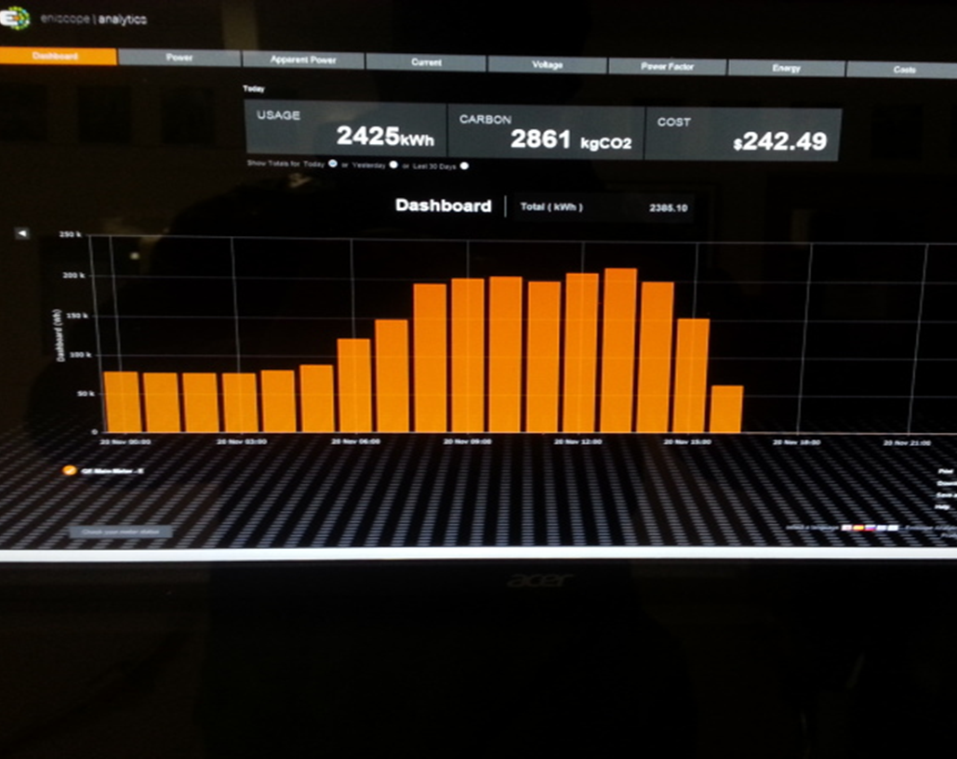

This data encourages students to experiment with reducing waste energy ie: turning off the gym lights and studying the savings in real time. From here we launched campaigns to inform necessary infrastructural and behavioral changes to reduce the carbon footprints of large buildings. Students are at school all day and have the capacity to observe energy usage patterns once they know what to look for. This is valuable information that can be provided to facilities managers with more information on inefficiencies and build a community of expertise that supports the learning of students.

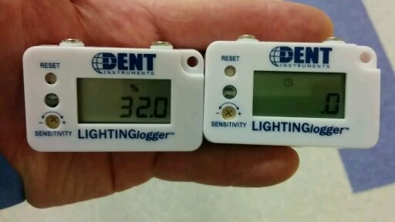 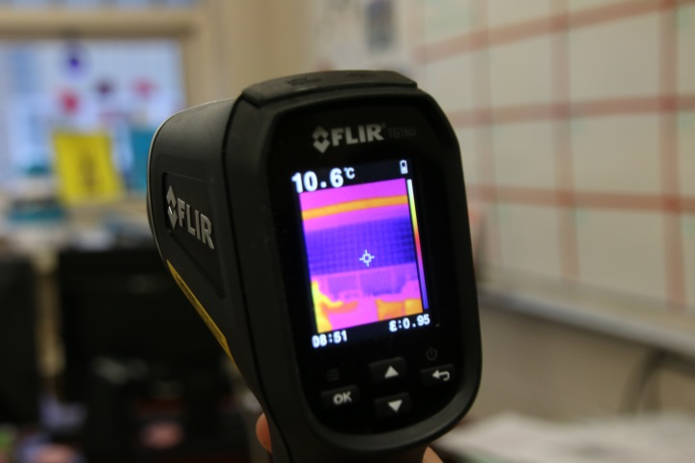

*Dent meters: amount of light Thermal scanner: heat loss and efficiency of windows, cladding, doors, etc…*

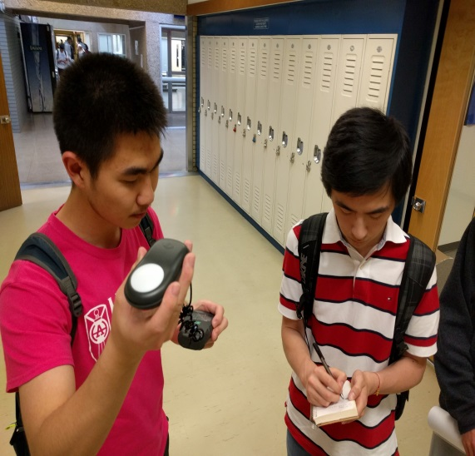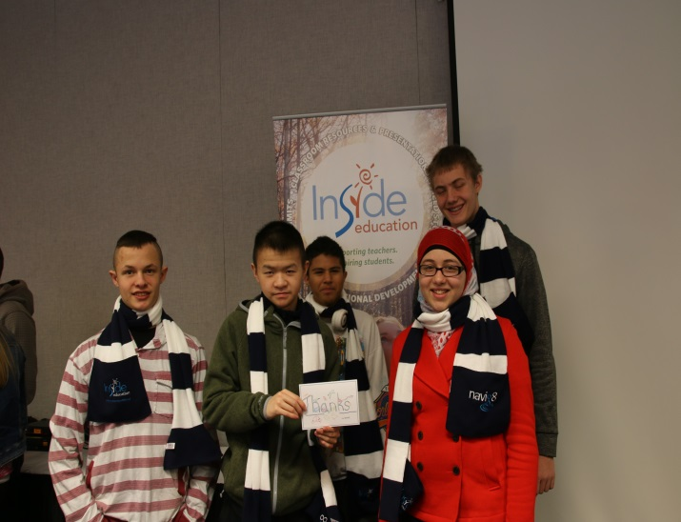

*Students testing lumens Students presenting energy auditing 101 at youth conference*

We took the smart metering one step further and had students approach local recreation facilities to install highly sensitive monitoring devices called Circuit meters. Students can monitor energy consumption of these buildings remotely, they create their own graphs based on power drawn from each circuit. They communicate their discoveries to decision makers and suggest ways of reducing operational costs and environmental impacts. The project has expanded by installing 2 circuit meters systems in city hall as that is the nexus of decision making. Students hope to influence council on energy efficiency measures.

Video:

[Innovate Program Overview](https://drive.google.com/file/d/1uFJF61P-tTkM720O1KXUQZ6vHMDpgBAk/view?usp=sharing)

3D PRINTING:

3D printing or Additive Manufacturing Layering is a sustainable act in that people can create things they need while being less reliant on the industrial machine. 3D printing is analogous to the pre-industrial age of the cottage industry where items were made in localized settings and based on need. We use a printing filament (material) called PLA which is essentially a plant based material. Students learn how to operate and maintain machines and print for things they will use, for school projects and for others. It also allows for innovation which requires ideas and tools or pathways of making ideas happen. Students are always inspired by the technology once they begin seeing its wide spread applications.

Our most iconic co-created 3D initiatives are hand-a-thons where we print prosthetic hands for kids in need. These events occur in either Edmonton or Calgary schools and involve PrintYourMind3D company from Calgary, volunteer members from Alberta’s professional association of engineers and geophysicist, APEGA, a humanitarian organization such as Enable and students from several high schools. Experienced 3D printing students were required to help organize the hand-a-thons and to train the volunteers on how to build the hands from printed components. Again, we experienced students of the highest academic achievement working with at-risk youth to help people receive 3D hands for free.

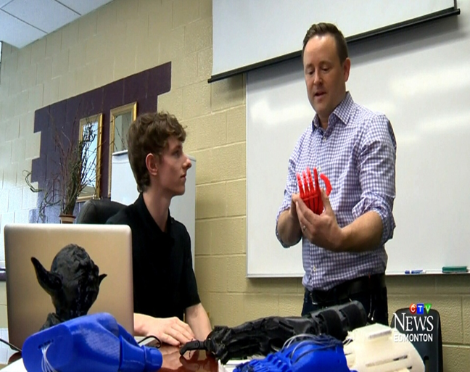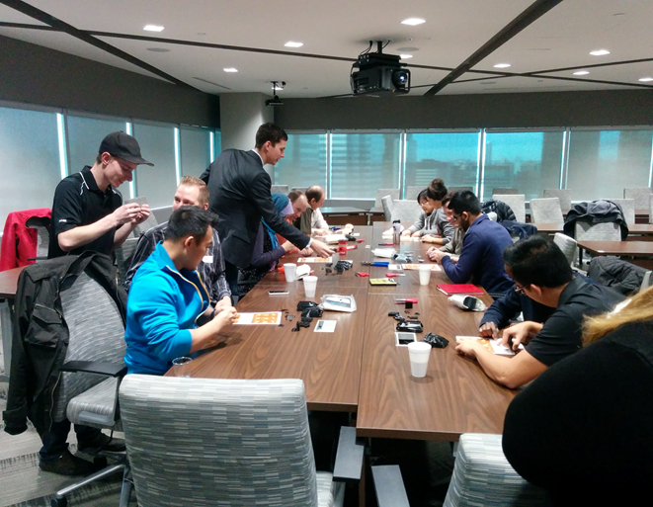

Testing hands Students teaching APEGA professionals how to build hands so they could volunteer for hand-a-thon

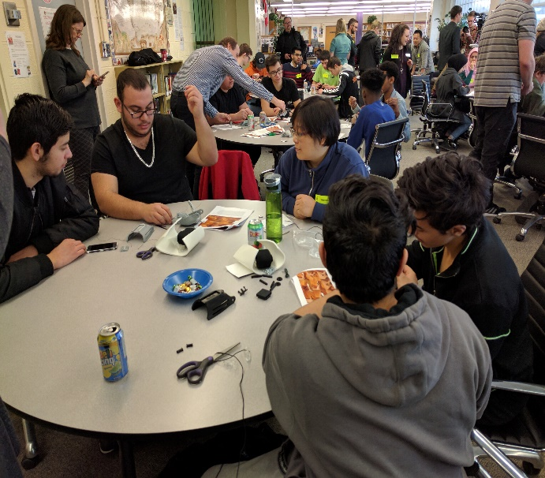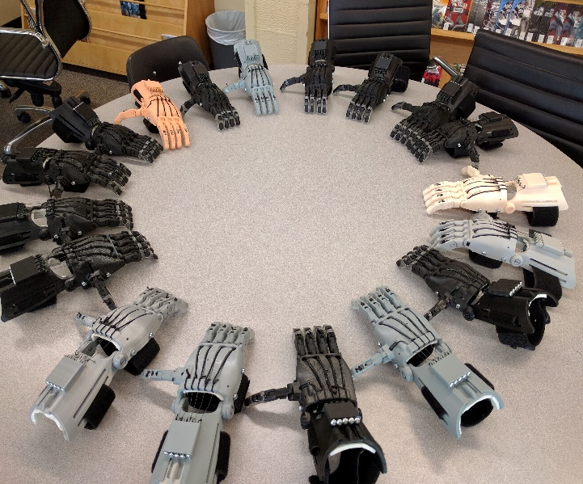

*Students building hands Have built and given out over 40 prosthetic hand*

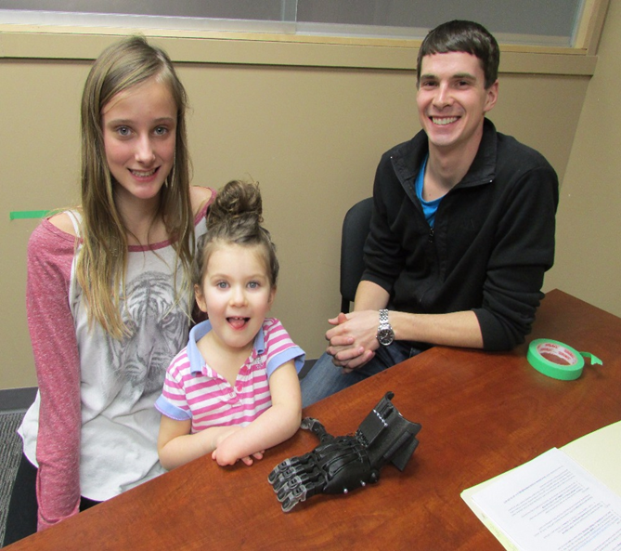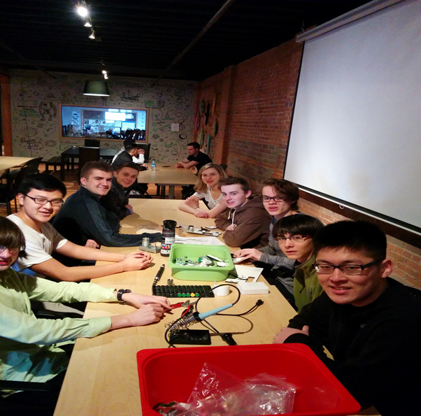

*4 year old Clara from Calgary receiving a hand. First time she could hold a book by herself or catch a ball. Students building a filastruder – machine that recycles waste plastic into 3D filament.*

**Mosaic of Youth Voices on Climate Change**

Students are developing a series of podcasts tilted “The Mosaic of Youth Voices on Climate Change”. They create questions on this topic, interview their peers to record different youth perspectives and or be interviewed to share their perspectives. The interview recordings will be edited into 15-20 minute podcasts with the help of professional editors at CJSR Radio station and aired on Terra Forma. Edmonton’s historian laureate is helping guide the process to ensure these youth voices become archivable and part of Alberta’s history. Youth perspectives are gaining prominence in western culture through social media, school programs that emphasize local and global issues and through membership in interest groups which are connected across the world through online communities. Students have greater access to information via the internet and this allows them to become more aware of issues and to challenge or support government decisions that impacts their futures. In Alberta today, youth are faced with economic and environmental uncertainties resulting from a decline in global demands of fossil fuels and from an increased effort to curb the dangers of climate change. School curriculum emphasizes climate change topics and stress innovation in energy sectors. It is critical to consider the views of youth and to address their interests in schools and through civic engagement. The mosaic of voices is an opportunity for youth to share their perspectives on the future of Alberta. Questions such as: “What is climate change? How is it impacting our community? What should Albertans do to mitigate climate change? What do youth want for their futures in this province? are being considered for the mosaic.

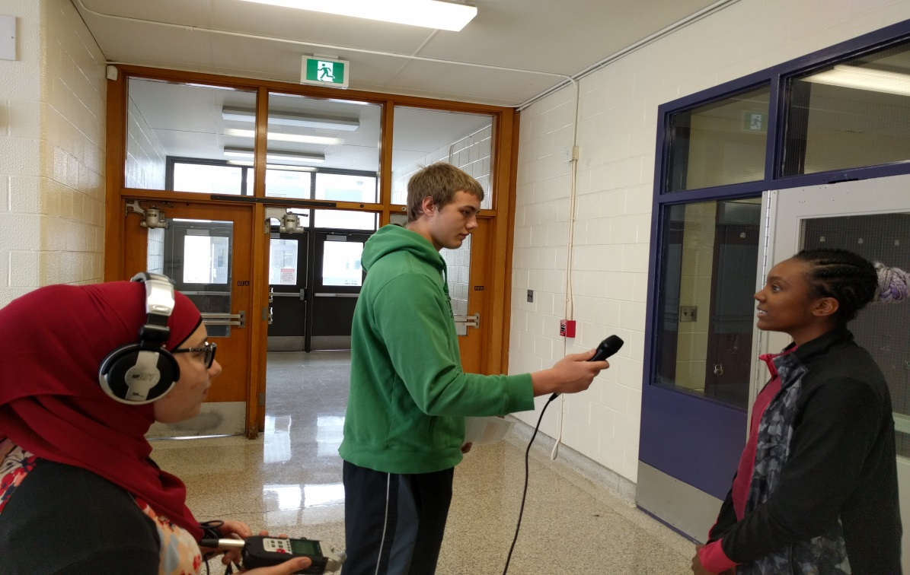 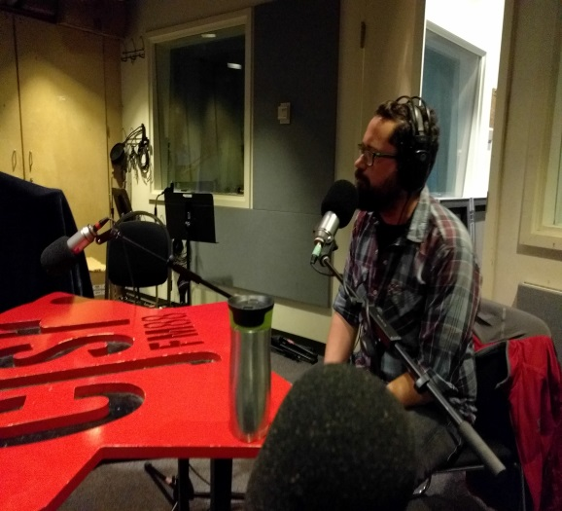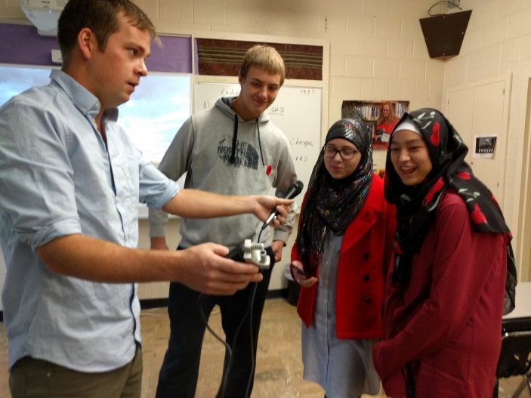

*Top: Students interviewing their peers. Bottom left: Innovate Elementary teacher James Stuart being interviewed by CJSR radio station. Bottom Right: Innovate High School teacher Ian Potts training students with field radio equipment purchased through grants.*

OTHER PROJECTS:

***MicroWindTurbine competitions***

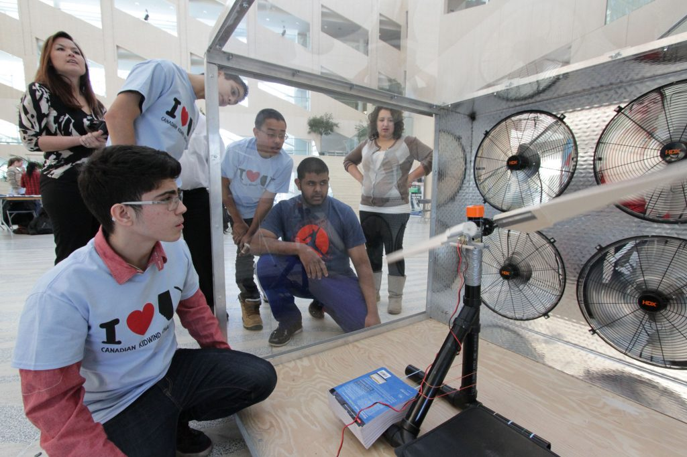

*High school students built and tested* ***microwind turbines*** *at City Hall through Lethbridge colleges “KidWind” Challenge. Later events incorporated 3D design and printing of microwind turbine blades.*

***Horticultural Career Fairs***

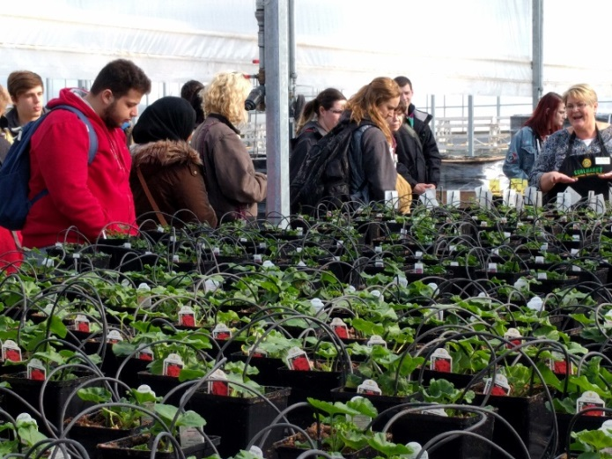 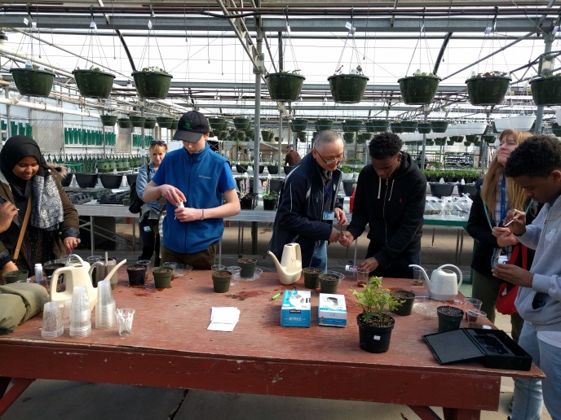

*Hands-on* ***Horticultural Career Fairs*** *in greenhouse facilities to connect youth to career pathways in agricultural related fields*

***Innovate Days***

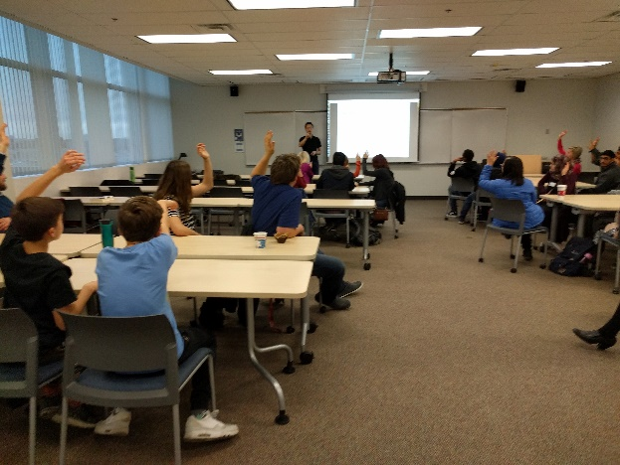 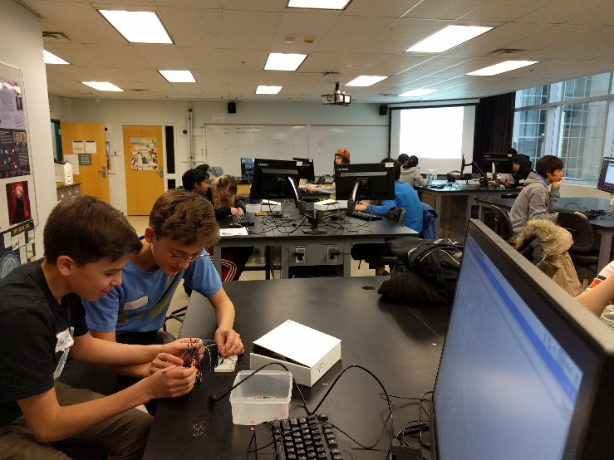

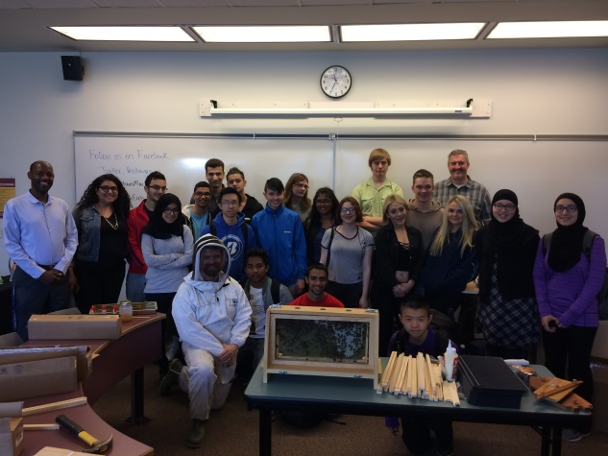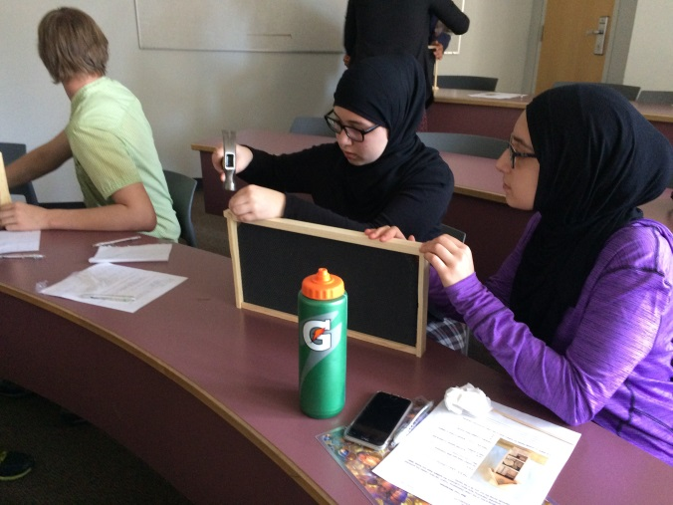

***INNOVATE DAYS*** *at MacEwan University where professors put on innovative workshops in social enterprise, urban beekeeping and microcontrollers for 100 students and 20 teachers (who used the event as professional development in STEM(A) education alongside the youth they teach). Students developed innovative and sustainable sets of skills and knowledge while gaining a window into life in post-secondary institutions for easier transitions to career pathways.*

***Landscaping and Outdoor Gardening***

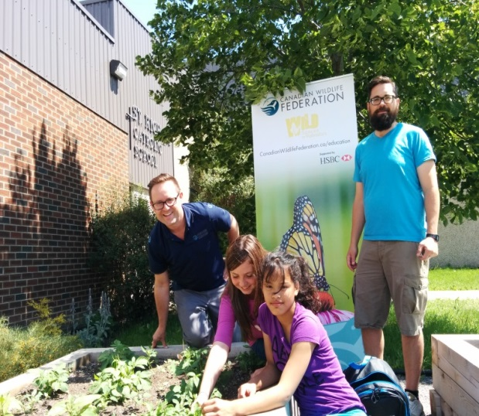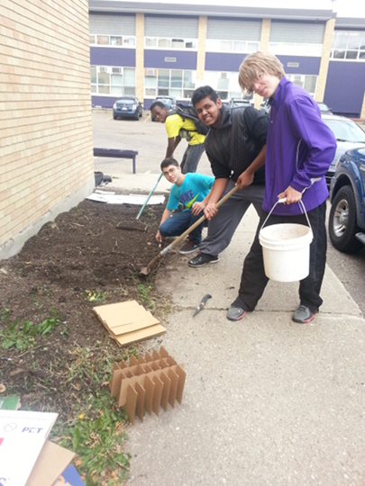

*Outdoor gardening and school campus beautification projects. High school students earn CTS credits in agricultural landscape and design courses.*

**Computer Building: repurposing old technology**

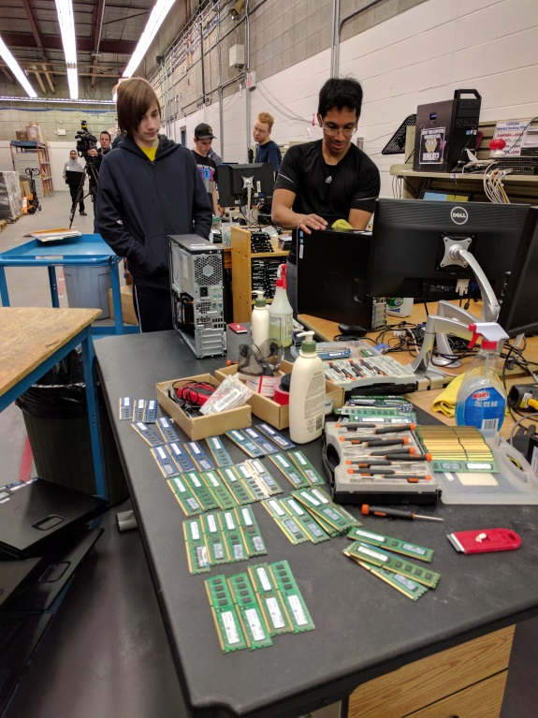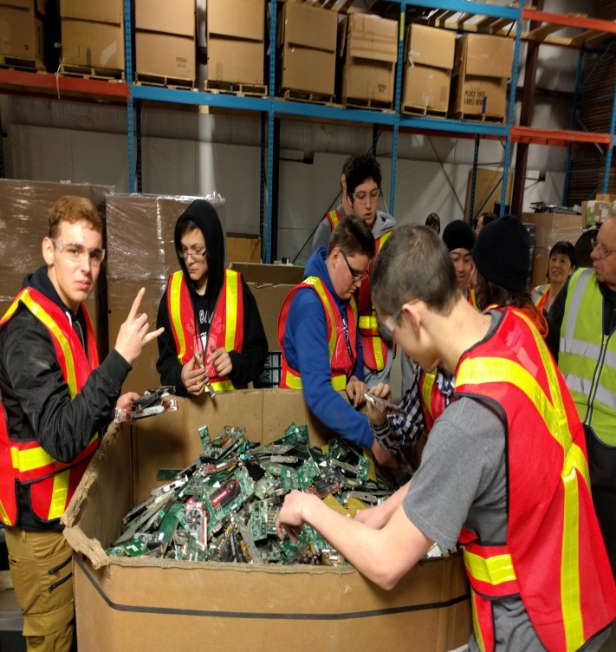

*Computing science students from the University and Technical colleges volunteer to teach Innvoate students how to build computers. Parts, such as graphics cards, were scavenged from our local Electronic Recycling centre.*

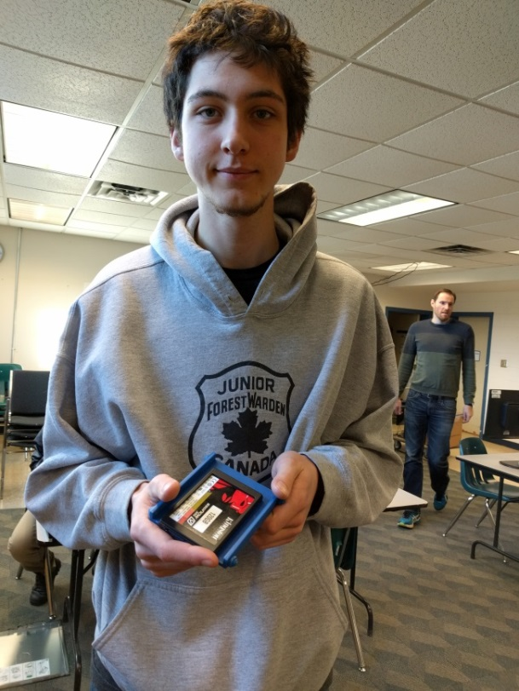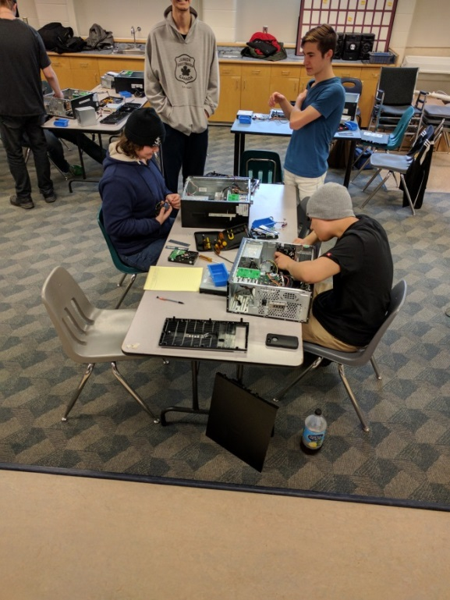

*Student designed and 3D printed new sturdier case for SSD component of his computer. Students collaborating to rebuild and improve old computers.*

INNOVATE ELEMENTARY

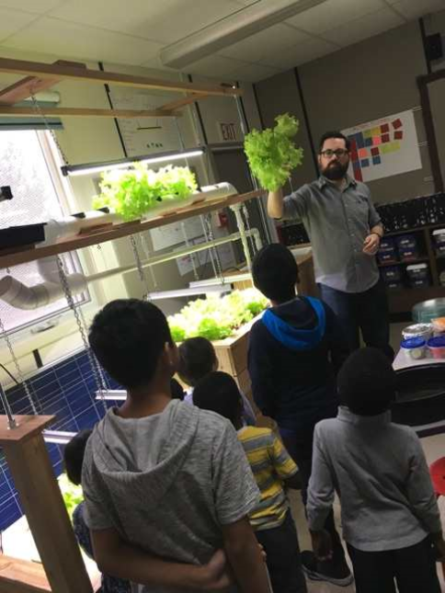

*Innovate Elementary school teacher James Stuart introducing aquaponics to a grade 5 class. Normalizing education for sustainable development throughout the early years.*

There are many forms of hand-on/project-based learning programs. These initiatives teach youth what’s possible while simultaneously placing them in real world contexts doing projects that strengthen the greater community. In this way, students link their education to relevant application and can use their knowledge to work on solutions to problems. Such programming is essential to Alberta and Canada’s future in energy transitions and economic diversification. Students can be innovative and can develop solution oriented mindsets with clearer visions of what careers they will pursue and how they can pursue those careers.